National University of Computer and Emerging Sciences

COAL Lab Midterm

Computer Organization and Assembly Language

|  |  |  |  |  |
| --- | --- | --- | --- | --- |
| **Time Allowed** | 90 Minutes | **Student Name** | |  |
| **Maximum Marks** | 100 | **Roll Number** | |  |
| **Lab Instructors** | Hazoor | | **Date** | 26th Oct 2022 |

**Before you start make sure:**

1. **Fill word Format on GCR & submit PDF [Only PDF formats accepted]**
2. **PLAGIARISM WILL BE MARKED ZERO WITH NO RETAKE**

# **Activity 1: [20 Marks]**

Initialize a memory array with last 4 digits of **Your Own Roll Number** (for example, if your roll number is **16L-4195** then memory array should be initialized with **{4,1,9,5}**).

Then write a subroutine **LoadMN** which stores the matrices $M$ and $N$ using the values as described in the code section below:

# **Activity 2: [50 Marks]**

Use the subroutine from **Activity 1**, to initialize matrices **M** and **N.**

**Theory**:

If M and N are two matrices of order 2x2 as shown below

$$M =\left[\begin{matrix}a & b \\ c & d\end{matrix}\right]$$

$$N =\left[\begin{matrix}d & c \\ b & a\end{matrix}\right]$$

Multiplication of two matrices can be calculated by dot product of every row of $M$ with columns of $N$ as shown below:

$$O =MN=\left[\begin{matrix}a & b \\ c & d\end{matrix}\right]\left[\begin{matrix}d & c \\ b & a\end{matrix}\right]=\left[\begin{matrix}Mrow1*Ncol1 & Mrow1*Ncol2 \\ Mrow2*Ncol1 & Mrow2*Ncol2\end{matrix}\right]=\left[\begin{matrix}\left[\begin{matrix}a & b\end{matrix}\right]\left[\begin{matrix}d \\ b\end{matrix}\right] & \left[\begin{matrix}a & b\end{matrix}\right]\left[\begin{matrix}c \\ a\end{matrix}\right] \\ \left[\begin{matrix}c & d\end{matrix}\right]\left[\begin{matrix}d \\ b\end{matrix}\right] & \left[\begin{matrix}c & d\end{matrix}\right]\left[\begin{matrix}c \\ a\end{matrix}\right]\end{matrix}\right]$$

$$O =\left[\begin{matrix}ad+b^{2} & ac+ba \\ cd+db & c^{2}+da\end{matrix}\right]$$

As shown above, 1st element of $O$ can be calculated by dot product of 1st row of $M$ and 1st col of $N$, and so on.

**Write a subroutine which performs 2x2 matrix multiplication using the code below:**

# **Activity 3: [30 Marks]**

Make a subroutine for printing a matrix from **Activity 2** on the console as shown below

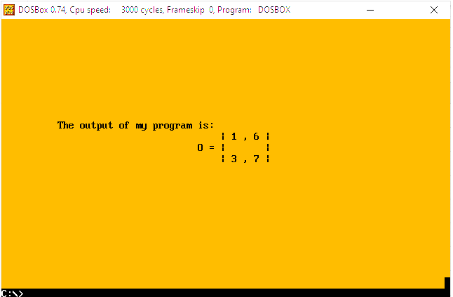

# **Code: [30 Marks]**

**Your final program structure should look like:**

[org 0x100]

jmp start

roll: db **4,1,9,5 ;** Change to last 4 digits of your roll number

a: db 0 ; store roll

b: db 0 ; store roll+1

c: db 0 ; store roll+2

d: db 0 ; store roll+3

; rows of M matrix of order 2X2

Mr1: db 0, 0 ; store a, b

Mr2: db 0, 0 ; store c, d

; rows of N matrix of order 2X2

Nr1: db 0, 0 ; store d, c

Nr2: db 0, 0 ; store b, a

; rows of O matrix of order 2X2

Or1: dw 0, 0

Or2: dw 0, 0

**LoadMN**:

; Write code for **LoadMN**

**MatMul**:

; Write code for Matrix Multiplication of 2x2 matrices

**PrintMat**:

; Write code for Printing Matrix

start:

;____________________________

; Write Calls to the subroutines & other codes here

;____________________________

mov ax, 0x4c00

int 0x21